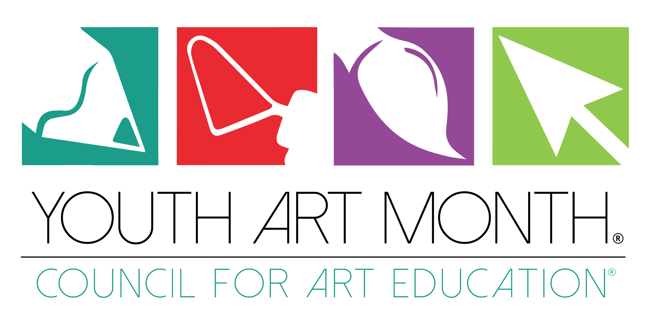

CERTIFICATE of RECOGNITION

By virtue of the authority vested by the Constitution in the Governor of Florida, there is hereby officially recognized:

YOUTH ART MONTH

WHEREAS: art education contributes powerful educational benefits to all elementary, middle and secondary students; and
WHEREAS: art education develops students’ creative problem-solving and critical thinking abilities; and
WHEREAS: art education teaches sensitivity to beauty, order, and other expressive qualities; and
WHEREAS: art education gives students a deeper understanding of multi-cultural values and beliefs; and
WHEREAS: art education reinforces and brings to life what students learn in other subjects; and
WHEREAS: art education interrelates student learning in art production, art history, art criticism, and aesthetics; and
WHEREAS: support should be given to art teachers as they attempt to strengthen art education in their schools and communities;

NOW, THEREFORE, I RON DESANTIS, do hereby recognize March 2021 as YOUTH ART MONTH in our STATE OF FLORIDA, and I call this observance to the attention of all our citizens.

